**CODE:**

<!DOCTYPE html>

<html lang="en">

    <head>

        <meta charset="UTF-8">

        <meta name="viewport" content="width=device-width, initial-scale=1.0">

        <title>Document</title>

    </head>

    <body>

        <h1>Welcome to My Portfolio</h1>

        <h1>Velpula Usha</h1>

        <p>I am a passionate web developer with focus on front-end technologies.</p>

        <p>I am currently Pursuing my MCA in <em> Ms.Ramaih university </em>Bangalore</p>

        <p>I have learnt Web Development from <br>Code with Swaroop</p>

        <p>You can <strong>Click here</strong> to Checkout what i have learnt in HTML</p>

        <h1>My Skills</h1>

        <ol>

           <li>Python Basics</li>

           <li>HTML Basics</li>

           <li>CSS Basics</li>

           <li>JavaScript Basics</li>

        </ol>

    </body>

</html>

* OL🡪ordered list
* LI🡪listed items

**OUTPUT:**

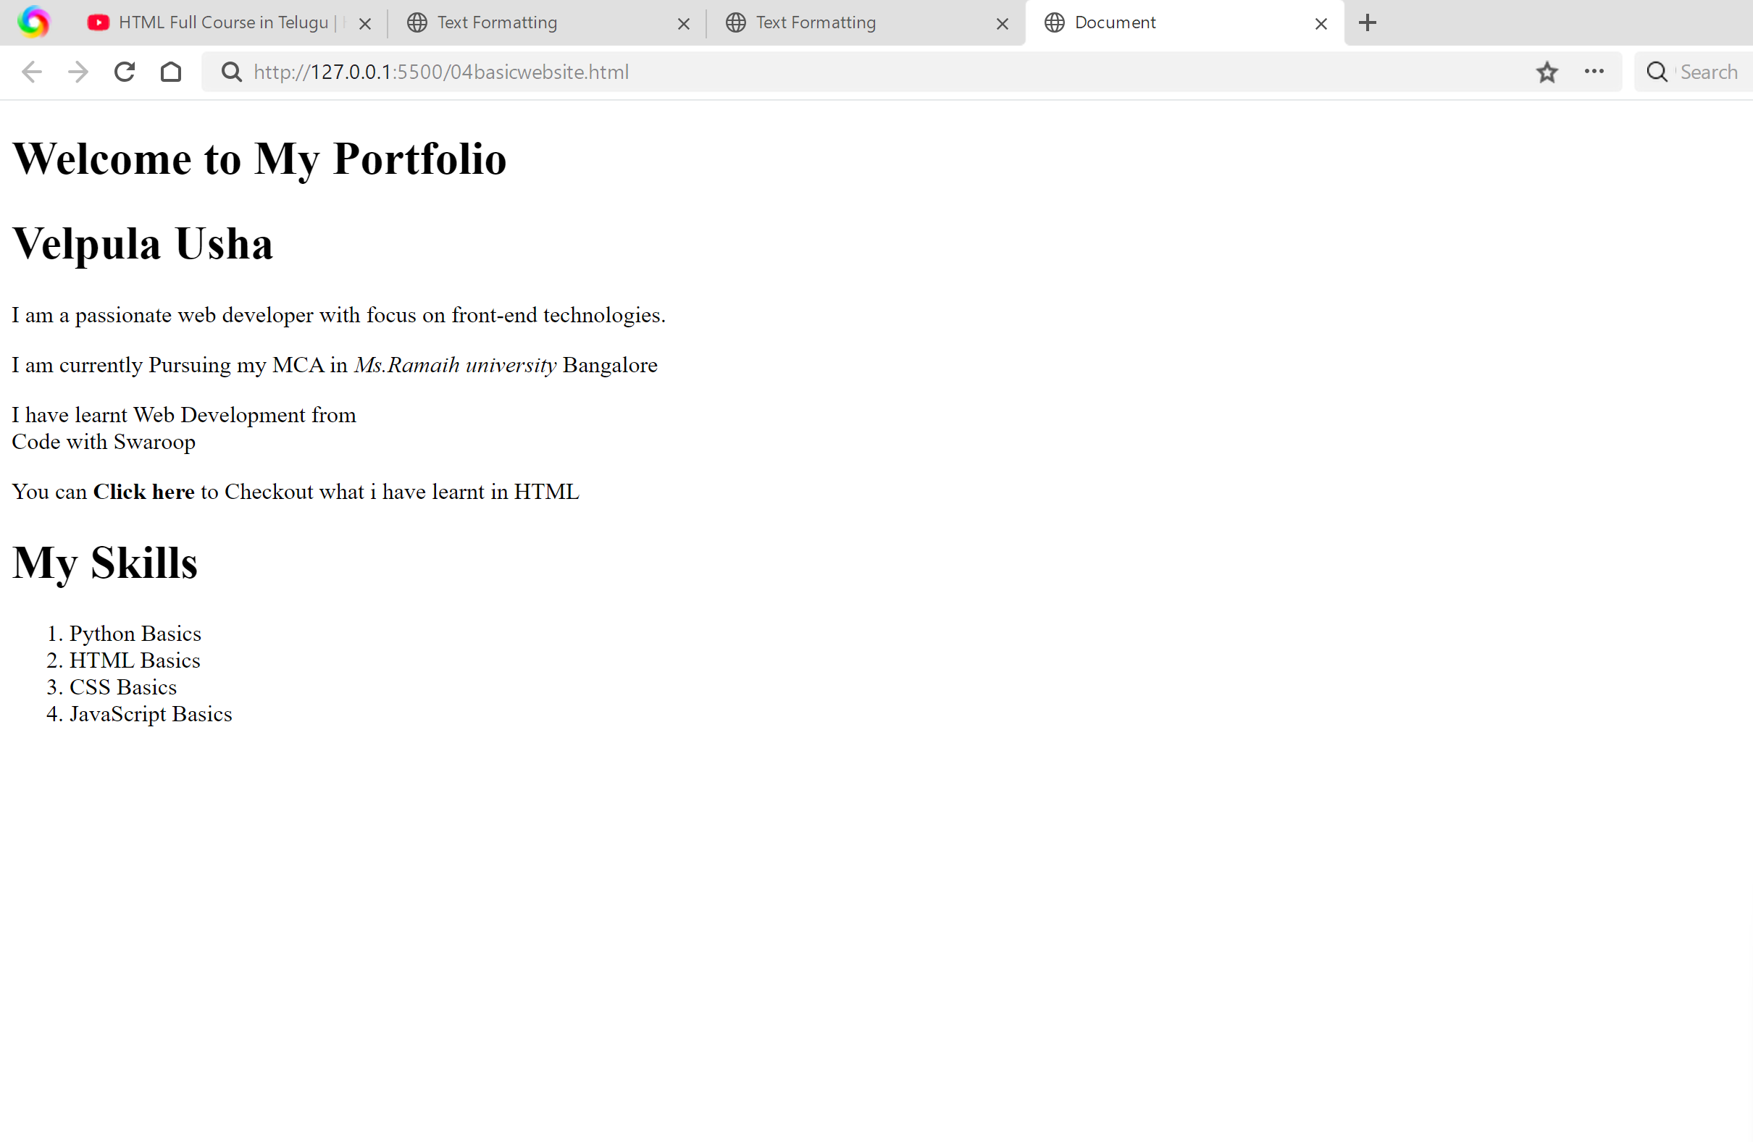

**CODE:**

<!DOCTYPE html>

<html lang="en">

    <head>

        <title>FormElements</title>

    </head>

    <body>

        <h1> Form Elements </h1>

        <form>

            <input>

        </form>

    </body>

</html>

**OUTPUT:**

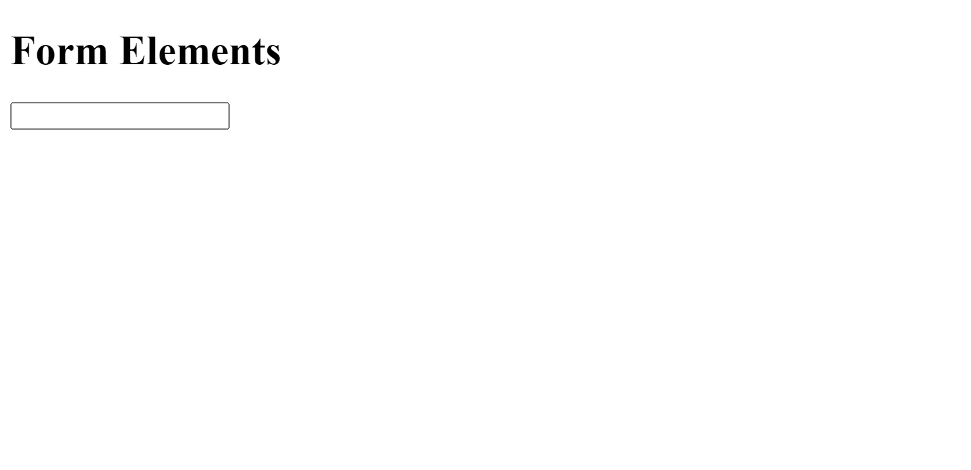

**CODE:**

<!DOCTYPE html>

<html lang="en">

    <head>

        <title>FormElements</title>

    </head>

    <body>

        <h1> Form Elements </h1>

        <form>

            <label>UserName:</label>

            <input>

        </form>

    </body>

</html>

**OUTPUT:**

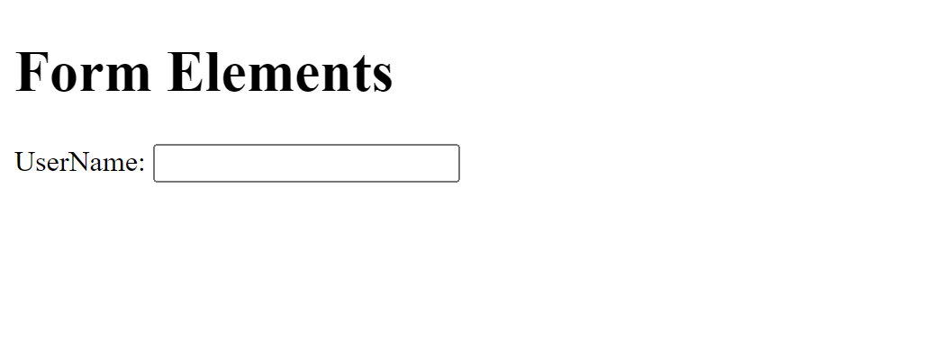

**Code:**

<!DOCTYPE html>

<html lang="en">

    <head>

        <title>FormElements</title>

    </head>

    <body>

        <h1> Form Elements </h1>

        <form>

            <label for="UserName" >UserName:</label>

            <input type="text" id="UserName" name="UserName" placeholder="enter username">

        </form>

    </body>

</html>

**OUTPUT:**

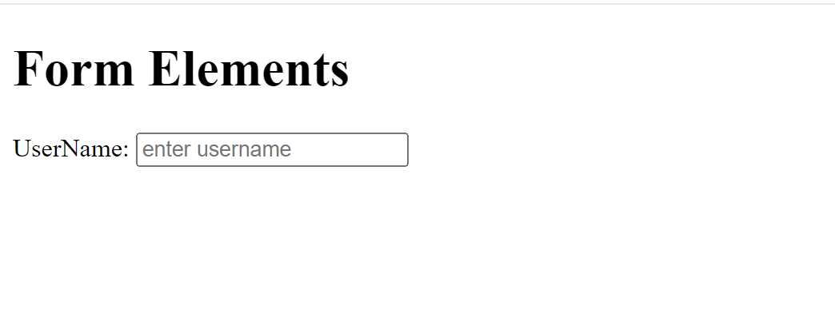

**Button**

<h1>Welcome to My Portfolio</h1>

        <a href="">

            <button>About</button>

        </a>

        <h1>Velpula Usha</h1>

**OUTPUT:**



**Code:**

        <h1>Welcome to My Portfolio</h1>

        <a href="">

            <button>About</button>

        </a>

        <a href="">

            <button>Skills</button>

        </a>

        <a href="">

            <button>Projects</button>

        </a>

        <a href="">

            <button>Contact</button>

        </a>

        <h1>Velpula Usha</h1>

OUTPUT:



**CODE:**

        <h1>Contact Me</h1>

        <p>Feel free to get in touch with me using the below details</p>

        <form action="">

            <label for="name">Name:</label>

            <input type="text" id="Name" name="Name">

            <br>

            <label for="email">Email:</label>

            <input type="text" id="Email" name="Email">

            <br>

            <b>Choose your Gender</b>

            <input type="radio" id="male" value="male">

            <label for="male">Male</label>

            <input type="radio" id="female" value="female">

            <label for="female">Female</label>

            <br>

            <b>Select your interests:</b>

            <input type="checkbox" id="coding" value="coding">

            <label for="coding">Coding</label>

            <input type="checkbox" id="reading" value="reading">

            <label for="reading">Reading</label>

            <br>

            <label for="bio">Bio (up to 200 characters):</label>

            <input type="text" id="bio">

            <br>

<button type="submit">Submit</button>

        </form>

**OUTPUT:**

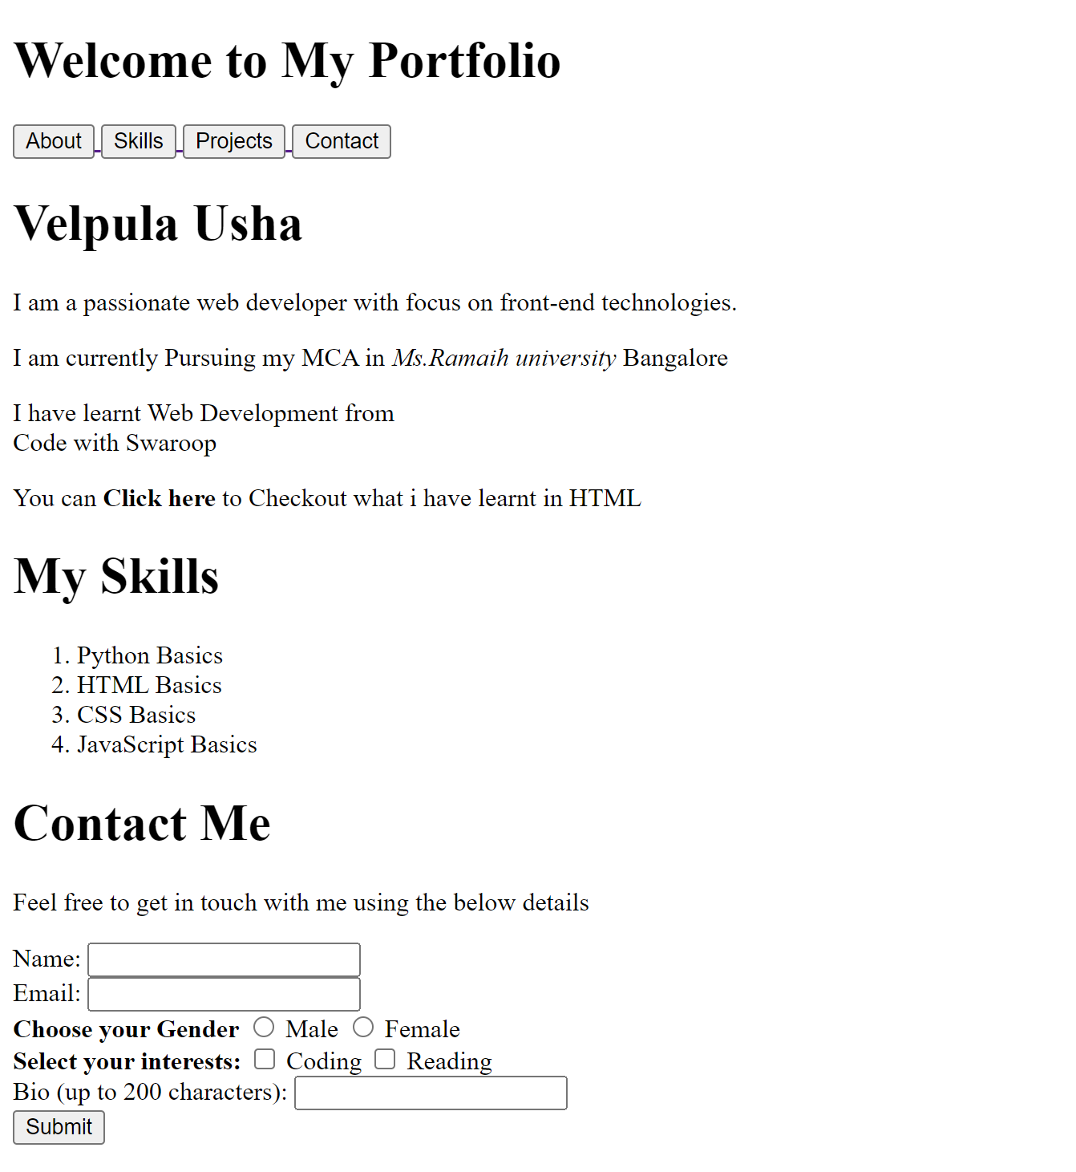

**Image.html**

**CODE:**

<!DOCTYPE html>

<html lang="en">

<head>

    <meta charset="UTF-8">

    <meta name="viewport" content="width=device-width, initial-scale=1.0">

    <title>Document</title>

</head>

<body>

    <img src="image.png">

</body>

</html>

**OUTPUT:**



**Video.html:**

**CODE:**

<!DOCTYPE html>

    <html lang="en">

    <head>

        <meta charset="UTF-8">

        <meta name="viewport" content="width=device-width, initial-scale=1.0">

        <title>Document</title>

    </head>

    <body>

        <iframe src="" frameborder="0"></iframe>

        <iframe width="560"

         height="315"

          src="https://www.youtube.com/embed/_buMdqF7o-A?si=eGA_0XpURjDAsnqY"

          title="YouTube video player"

          frameborder="0"

          allow="accelerometer; autoplay; clipboard-write; encrypted-media; gyroscope; picture-in-picture; web-share" referrerpolicy="strict-origin-when-cross-origin" allowfullscreen>

        </iframe>

    </body>

</html>

* We get the video link through “embed”
* Open youtube 🡪 open any vide in youtube🡪click on share button🡪there we can see the embed option🡪click on embed 🡪we get the code with “IFRAME” 🡪copy the code and paste on <body> LINK </body>.

**OUTPUT:**



**SEMANTIC TAGS:**

**<header>**

**<main>**

**<footer>**

**CODE:**

<!DOCTYPE html>

<html lang="en">

<head>

    <meta charset="UTF-8">

    <meta name="viewport" content="width=device-width, initial-scale=1.0">

    <title>Document</title>

</head>

<body>

    <header>

        <h1>This is Header</h1>

    </header>

    <main>

        <p>This is Main Content</p>

    </main>

    <footer>

        <p>This is footer</p>

    </footer>

</body>

</html>

**OUTPUT:**

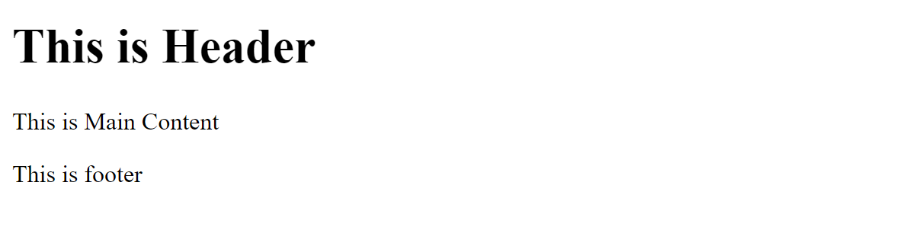

* <nav> 🡪constant
* Ex: google is we see google website

<nav>

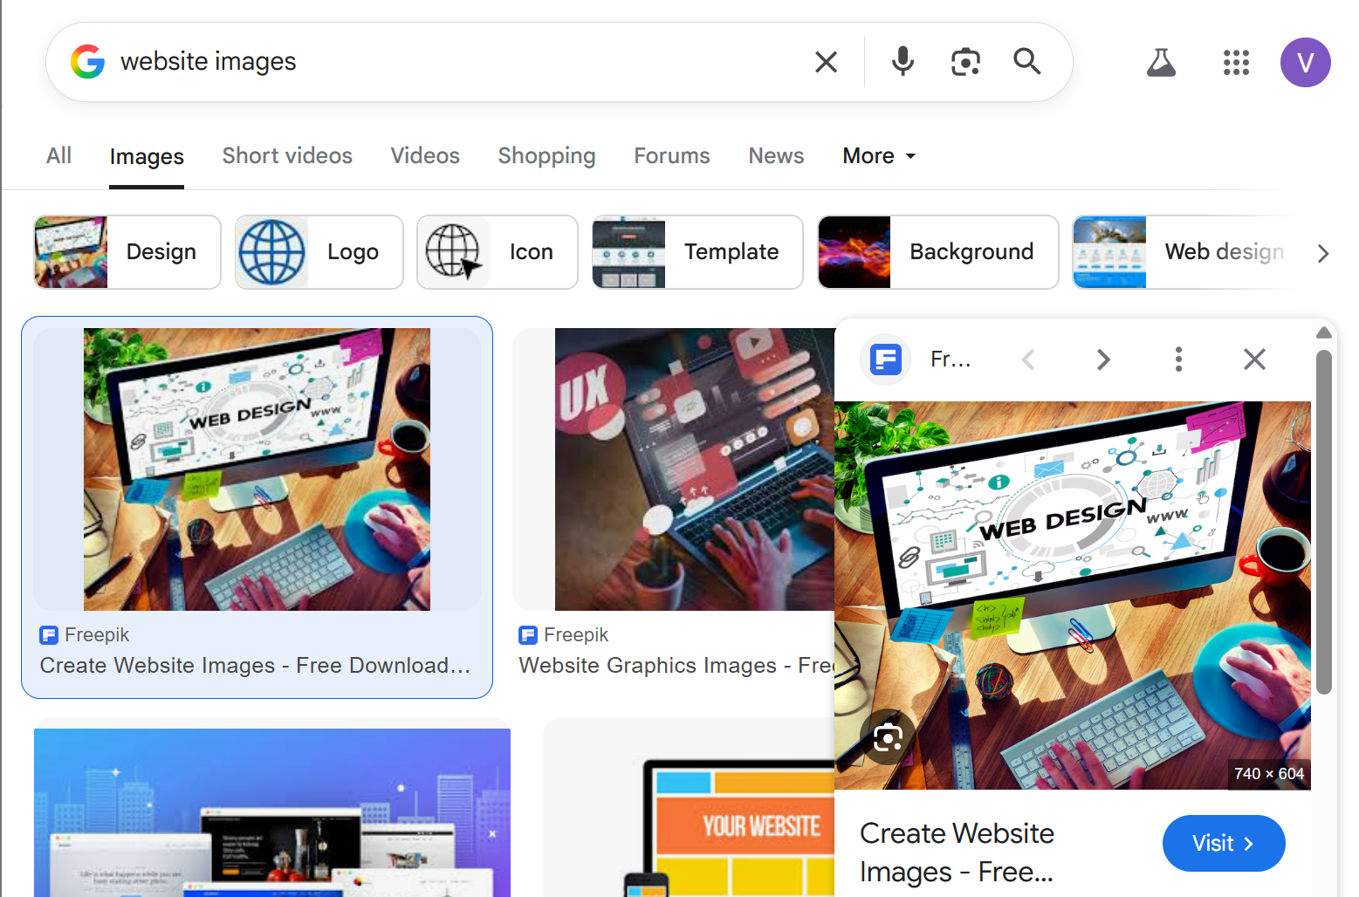

**Header**

**CODE:**

<!DOCTYPE html>

<html lang="en">

<head>

    <meta charset="UTF-8">

    <meta name="viewport" content="width=device-width, initial-scale=1.0">

    <title>Document</title>

</head>

<body>

    <header>

        <h1>This is Header</h1>

<nav>

</nav>

    </header>

</body>

</html>

**Main**

**CODE:**

<!DOCTYPE html>

<html lang="en">

<head>

    <meta charset="UTF-8">

    <meta name="viewport" content="width=device-width, initial-scale=1.0">

    <title>Document</title>

</head>

<body>

    <header>

        <h1>This is Header</h1>

<nav>

</nav>

    </header>

<main>

In main tag the information about wwebsite will be in main tag. It includes section,article and aside tags.

<section>

This is section.

</section>

<p> this is para </p>

</main>

</body>

</html>

Header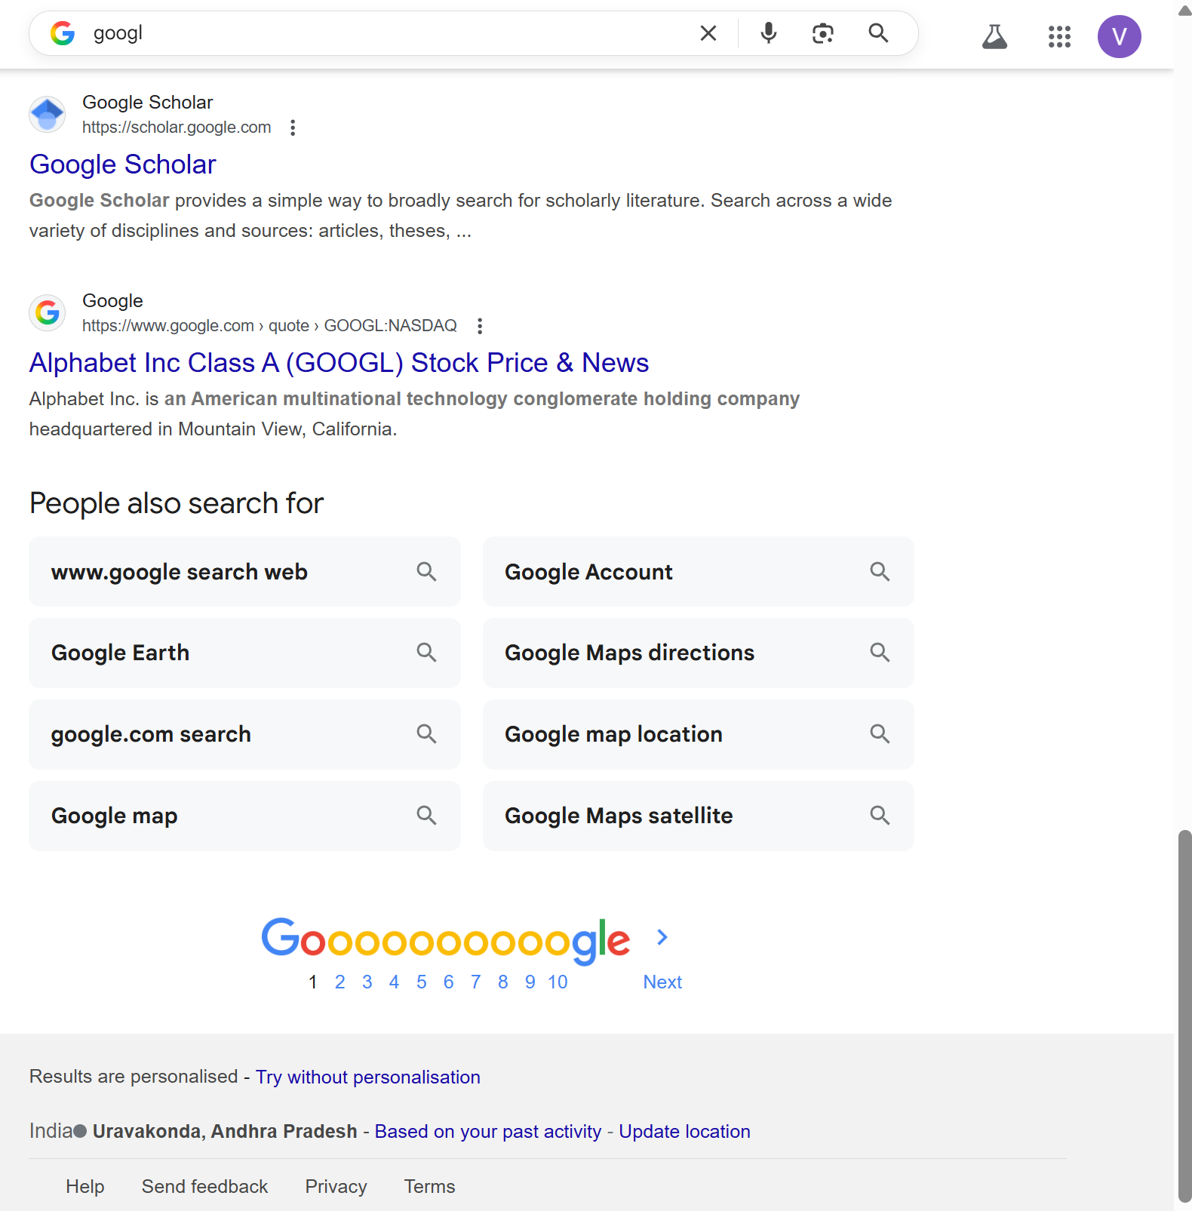

Footer main

**Non-Semantic tags:**

**<div>**

**<span>**

**<div>tag:**

**Code:**

<!DOCTYPE html>

    <html lang="en">

    <head>

        <meta charset="UTF-8">

        <meta name="viewport" content="width=device-width, initial-scale=1.0">

        <title>Document</title>

    </head>

    <body>

        <div>

            this is div element

        </div>

        <p> this is para </p>

    </body>

</html>

**OUTPUT:**

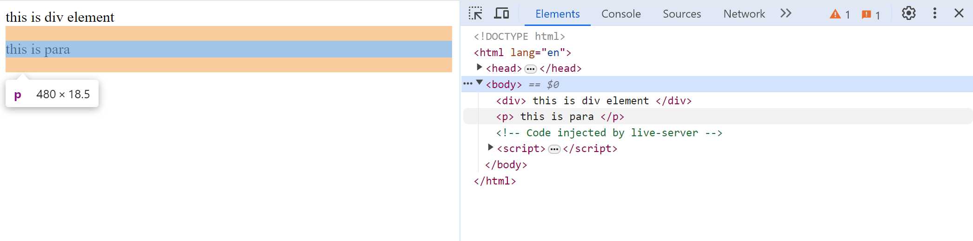

**<span>**

**Code:**

<!DOCTYPE html>

    <html lang="en">

    <head>

        <meta charset="UTF-8">

        <meta name="viewport" content="width=device-width, initial-scale=1.0">

        <title>Document</title>

    </head>

    <body>

        <div>

            this is div element

        </div>

        <p> this is para </p>

        <span>This is a span element</span>

    </body>

</html>

**OUTPUT:**

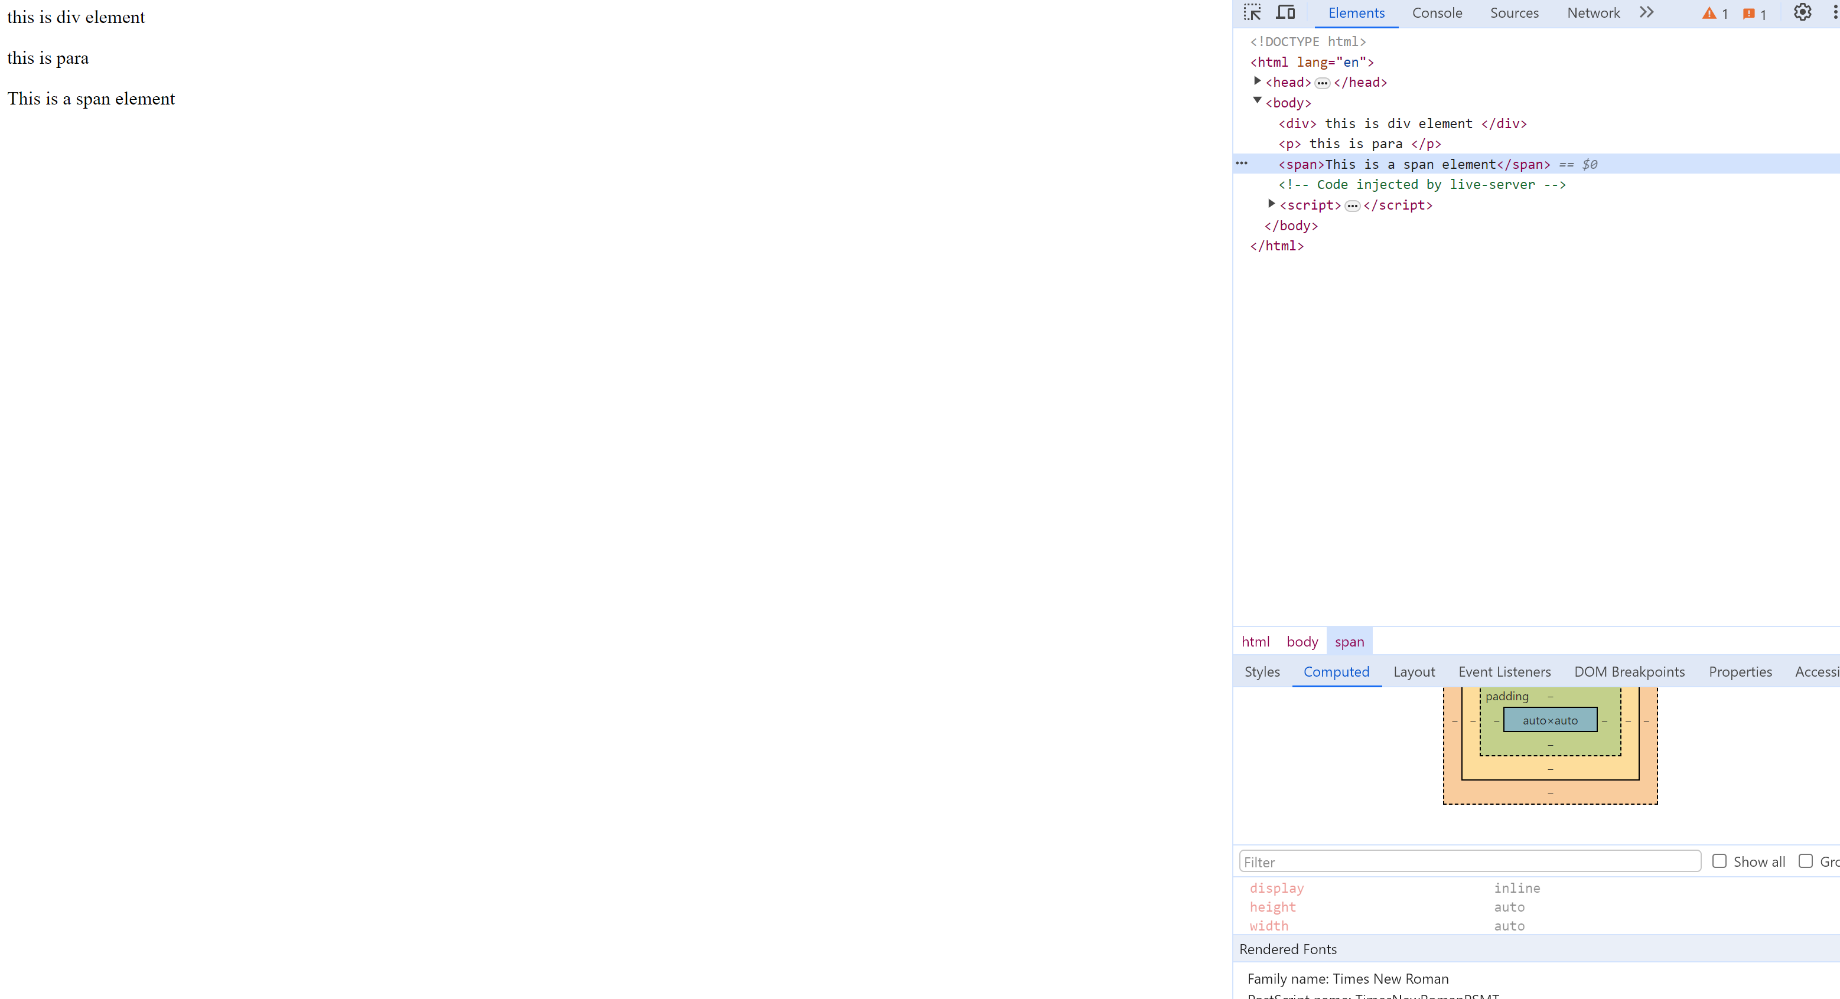

Inline element

**<span>** it is inline element🡪 means it takes only the space it needed, as shown below.

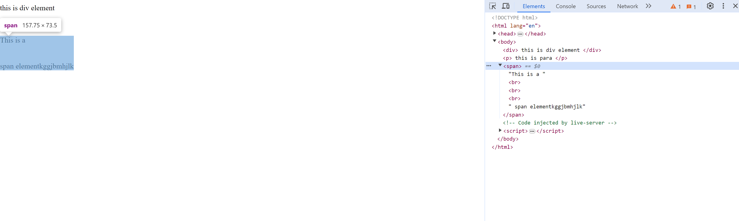

<span> tag is used to keep every span separated by its space. Span 1 span 2

